1. **Fine Calculation:** Calculate the total fines owed by each member, considering overdue books and a daily fine rate (e.g., $0.25 per day):

SELECT

c.unique_id AS member_id,

c.name AS member_name,

ROUND(SUM(

CASE

WHEN bb.due_date < COALESCE(bb.return_date, CURRENT_DATE)

THEN DATEDIFF(COALESCE(bb.return_date, CURRENT_DATE), bb.due_date) * @daily_fine_rate

ELSE 0

END

), 2) AS total_fine

FROM

Client c

LEFT JOIN

BookBorrowing bb ON c.unique_id = bb.client_id

LEFT JOIN

DigitalMediaBorrowing dmb ON c.unique_id = dmb.client_id

LEFT JOIN

MagazineBorrowing mb ON c.unique_id = mb.client_id

WHERE

c.account_status = 'Active'

GROUP BY

c.unique_id, c.name

HAVING

total_fine > 0;

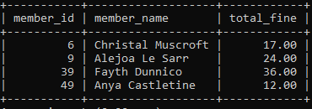

1. **Book Availability:** Display a list of all available books (not currently borrowed) within a specific genre.

SELECT b.ISBN, b.title, b.author, b.publication_year, b.genre, b.publisher

FROM Book b

JOIN Book_Copy bc ON b.ISBN = bc.ISBN

WHERE bc.status = 'Available'

AND b.genre = 'Science Fiction';

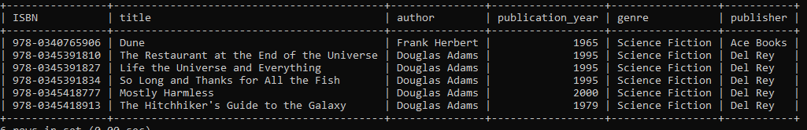

1. **Frequent Borrowers of a Specific Genre:** Identify the members who have borrowed the most books in a particular genre (e.g., "Mystery") in the last year.

SELECT

c.unique_id AS member_id,

c.name AS member_name,

COUNT(bb.item_id) AS books_borrowed,

b.genre

FROM

Client c

JOIN

BookBorrowing bb ON c.unique_id = bb.client_id

JOIN

Book_Copy bc ON bb.item_id = bc.copy_id

JOIN

Book b ON bc.ISBN = b.ISBN

WHERE

b.genre = 'Fantasy’'

AND bb.borrow_date >= DATE_SUB(CURDATE(), INTERVAL 1 YEAR)

GROUP BY

c.unique_id, c.name, b.genre

ORDER BY

books_borrowed DESC

LIMIT 10;

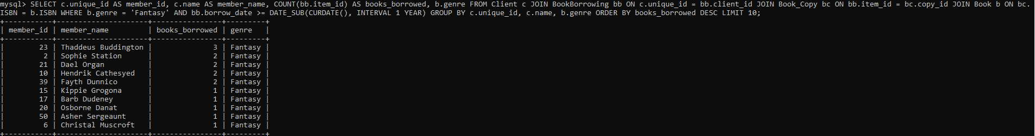

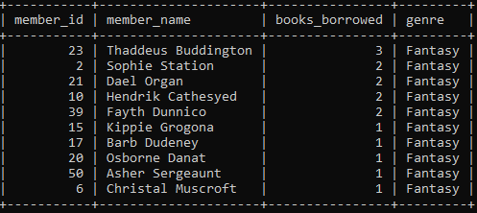

1. **Books Due Soon:** Generate a report of all books due within the next week, sorted by due date.

SELECT

bb.item_id AS book_copy_id,

b.title AS book_title,

b.ISBN,

c.name AS borrower_name,

bb.due_date

FROM

BookBorrowing bb

JOIN

Book_Copy bc ON bb.item_id = bc.copy_id

JOIN

Book b ON bc.ISBN = b.ISBN

JOIN

Client c ON bb.client_id = c.unique_id

WHERE

bb.due_date BETWEEN CURDATE() AND DATE_ADD(CURDATE(), INTERVAL 7 DAY)

ORDER BY

bb.due_date ASC;

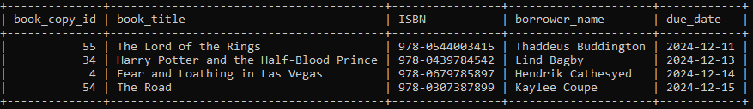

1. **Members with Overdue Books:** List all members who currently have at least one overdue book, along with the titles of the overdue books.

SELECT Client.name, Book.title

FROM Client

JOIN BookBorrowing ON Client.unique_id = BookBorrowing.client_id

JOIN Book_Copy ON BookBorrowing.item_id = Book_Copy.copy_id

JOIN Book ON Book_Copy.ISBN = Book.ISBN

WHERE

EXISTS (

SELECT 1

FROM BookBorrowing

WHERE client_id = Client.unique_id

)

ORDER BY

Client.name, Book.title;

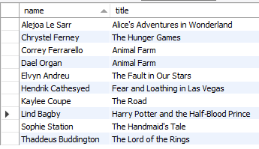

**Average Borrowing Time:** Calculate the average number of days members borrow books for a specific genre.

SELECT b.genre, AVG(DATEDIFF(COALESCE(bb.return_date, CURDATE()), bb.borrow_date)) AS average_borrow_days

FROM BookBorrowing bb

JOIN Book_Copy bc ON bb.item_id = bc.copy_id

JOIN Book b ON bc.ISBN = b.ISBN

WHERE b.genre = 'Fantasy' AND bb.borrow_date IS NOT NULL

GROUP BY b.genre;



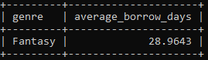

1. **Most Popular Author in the Last Month:** Determine the author whose books have been borrowed the most in the last month.

SELECT

b.author,

COUNT(bb.item_id) AS borrow_count

FROM

BookBorrowing bb

JOIN

Book_Copy bc ON bb.item_id = bc.copy_id

JOIN

Book b ON bc.ISBN = b.ISBN

WHERE

bb.borrow_date >= DATE_SUB(CURDATE(), INTERVAL 1 MONTH)

GROUP BY

b.author

ORDER BY

borrow_count DESC

LIMIT 1;



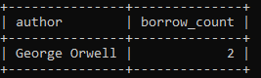

1. **Report 1: Generate a Collection Analysis Report:** This report should provide a comprehensive analysis of the library's book collection, examining the distribution of books by genre, identifying trends in acquisition over the past 5 years, and assessing the age of the collection to identify outdated materials. Highlight books with low circulation and analyze borrowing patterns to identify under-represented genres or authors. Your report should provide insights for collection development and management decisions

-- Books by genre

SELECT genre, COUNT(*) AS total_books

FROM Book

GROUP BY genre

ORDER BY total_books DESC;

-- Acquisition Trends

SELECT

IFNULL(YEAR(earliest_borrow_date), 'Not Borrowed Yet') AS acquisition_year,

COUNT(DISTINCT bc.copy_id) AS total_books

FROM

Book_Copy bc

LEFT JOIN (

SELECT

item_id,

MIN(borrow_date) AS earliest_borrow_date

FROM

BookBorrowing

GROUP BY

item_id

) bb ON bc.copy_id = bb.item_id

GROUP BY

acquisition_year

ORDER BY

acquisition_year;

-- Low circulation Books, shows a list of books having 5 or less borrows total and orders by lowest first

SELECT b.title, COUNT(bb.item_id) AS borrow_count

FROM Book b

JOIN Book_Copy bc ON b.ISBN = bc.ISBN

LEFT JOIN BookBorrowing bb ON bc.copy_id = bb.item_id

GROUP BY b.title

HAVING borrow_count < 5

ORDER BY borrow_count;

-- Borrowing Pattern by Genre

SELECT b.genre, COUNT(bb.item_id) AS borrow_count

FROM Book b

JOIN Book_Copy bc ON b.ISBN = bc.ISBN

JOIN BookBorrowing bb ON bc.copy_id = bb.item_id

GROUP BY b.genre

ORDER BY borrow_count DESC;

– Average age of books since publication

SELECT AVG(YEAR(CURDATE()) - publication_year)

FROM Book_Copy bc

JOIN Book ON bc.ISBN = Book.ISBN;

**Books by Genre:**

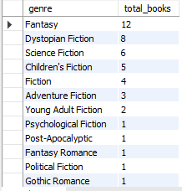

**Acquisition Trends:**



**Low Circulation Books:**

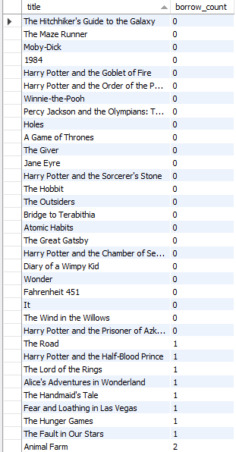

**Borrowing Pattern by Genre:**

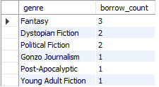

**Average time since book was published:**

SELECT AVG(YEAR(CURDATE()) - publication_year) as average_years_since_published

FROM Book_Copy bc

JOIN Book ON bc.ISBN = Book.ISBN;



**Outdated Books (Books published before average publishing time):**

SELECT Distinct(b.title), b.ISBN, author, publication_year, genre, publisher

FROM Book b

JOIN Book_Copy bc ON b.ISBN = bc.ISBN

WHERE (YEAR(CURDATE()) - b.publication_year) > (

SELECT AVG(YEAR(CURDATE()) - publication_year)

FROM Book b2

JOIN Book_Copy bc2 ON b2.ISBN = bc2.ISBN

);

